Artículo para [Agroecology and Food Sustainable Systems](http://www.tandfonline.com/action/authorSubmission?journalCode=wjsa21&page=instructions#.VdduM84XzC0)

Una posibilidad:

**Dynamics and vulnerability of the *Milpa* system under diverse management schemes and types of perturbations**

Rafael López Martínez1,2,3, Cecilia González González1,2,3, Luis García-Barrios, Juan Fornoni Agnelli, Miguel …, Mariana Benítez1,2*

1 Laboratorio Nacional de Ciencias de la Sostenibilidad, Instituto de Ecología, Universidad Nacional Autónoma de México, Mexico City, Mexico.

2 C3, Centro de Ciencias de la Complejidad, Universidad Nacional Autónoma de México, Mexico City, Mexico.

3 Posgrado en Ciencias Biológicas, Universidad Autónoma de la Ciudad de México, Mexico City, Mexico.

4 Maestría en Dinámica no Lineal y Sistemas Complejos, Universidad Autónoma de la Ciudad de México, Mexico City, Mexico.

*mbenitez@iecologia.unam.mx

**Running head (50 chars)**

Landscape agricultural management and biodiversity

**Key words (5-7)**

Agroecology, milpa, ecological network, boolean model, vulnerability, agricultural management

**Abstract (100 wds)**

**Introduction**

**The milpa as al study model in agroecology**

An agroecosystem is defined as the result of the interaction between biological, environmental and human-management factors on the agricultural land (Altieri, 1999). Agroecology approaches these systems and proposes to study and consider their complexity in order to plan their production, prevent possible complications (Levins, R.A. & J.H. Vandermeer, 1990). Also, agroecosystems are important components of the natural world and it has been proposed that certain production schemes can contribute to the maintenance of biodiversity inside and around them (Perfecto & Vandermeer, 2010; García-Barrios *et al*. 2009).

The most extended and diverse agroecosystem in Mexico is the *milpa,* a mesoamerican mixed farming technique that is still practiced today (Batrta, 2008). It can include maize, beans, squash, chili peppers, semi domesticated weeds, and many other plants and animals (Boege, 2008). The milpa has had a central role in the diversification of the plant species associated to it, and both its composition and its dynamics vary importantly with the cultural, climatic and geographic conditions in which it is found (Boege, 2008). Because it is an “ecological and evolutionary unit” (Benítez y Fornoni 2014 tesisCeci), the milpa offers a big potential for studying the way in which agro-communities are structured, constituting good subjects for the analysis of processes like the regulation of insects and plants that are potentially harmful for the harvests and the adaptation of the system to variations in the environmental conditions. Studying the milpa constitutes a chance to approach basic questions in community ecology (particularly, in communities where human influence represents a key factor for their functioning), and questions related to biodiversity conservation and sustainable management of agricultural production (e.g. pest management) (Morales & Perfecto, 1999; Golob, 1997).

Ecological communities are typically complex, i.e. its components tend to aggregate and interact with each other in a nonlinear way, resulting in emergent systemic properties (Cocho, 2011; Stephens, 2011; Bascompte, 2009). Among the emergent properties that seem to be central for ecological systems are diversity (considered as taxonomic or functional richness), resilience (a concept trated in this work as the individual and combined permanence of certain elements), and productivity.There are studies that show that both primary productivity and stability of certain ecosystems (e.g. perennial and annual grasslands, natural and artificial) seem to be directly related to the presence of a larger biological and ecological diversity (Tilman, 2012; Thébault y Fontaine, 2010; McNaughton, 1994). Nonetheless, the relationship between these properties has been scarcely studied in complex agroecosystems like the milpa. Conventionally, the focus of academics, engineers and policy makers has been centered on the productivity of agroecosystems, leaving the other important properties aside. Thus, there is a need for integral and dynamical approaches to study how these systemic properties emerge, interact with each other and are affected by perturbations.

The complexity of the milpa makes it difficult to predict its response to change and perturbations, consequently, in order to study its collective dynamics, it is necessary to develop models that formalize the relationships between the interacting factors that compose it. Dynamical models enable us to systematically integrate these ecological interactions between the components of the milpa and study the emergent properties that arise from them at the community level. In the other hand, the possibility to test and foresee, at least qualitatively, the effects of alterations in the ecological communities becomes specially relevant in the face of the actual biodiversity crisis and climate change. In this paper we intend to analyze the overall dynamic of the Milpa system and its vulnerability to different types of perturbations, as we consider it to be relevant when assessing the desirability of different management schemes in relation to possible disturbances (climatic change, pests, etc.). Understanding the milpa and other traditional systems as agroecological study models, combining the knowledge that arises from them with the traditional knowledge of the people who reproduce them, can result in key productive strategies for guaranteeing both healthy and diverse diets and biodiversity conservation, under actual and future changing conditions (Perfecto blabla naturesmatrix).

**Dynamical modelling and boolean networks**

The resilience of diverse agroecosystems has hardly been studied with a complex systems approach. In the present work, we theoretically studied the milpa as a model system in the context of Ecology and Agroecology. We defined the interactions between some representative elements of the ecological community in a variable climatic context and under different management schemes. This was done with the intention of obtaining a reasonable qualitative dynamic for the system that allowed the testing of the system’s resilience in relation to three types of perturbations: incidence of herbivores (pests), weeds, and dry season occurrence.

Typically, dynamic modelling of ecological networks has been done with differential equations (continuous approach). In most cases, the network’s components (nodes) represent taxonomically or functionally defined populations, while links between them (edges) represent ecological interactions that can be positive (e.g. mutualism or commensalism), negative (e.g. competence or ammensalism) or both (trophic relationships); and which reflect on the population size associated to each node (Bascompte, 2009; Dunne *et al.*, 2002). The dynamic arising from this is then used to define if the system is stable or not (MacArthur, 1954). This approach has been used for analyzing well characterized ecosystems and thus, for porposing the effects that certain changes in the local interactions can have over the whole system (Bascompte, 2009). These studies have allowed us to explore the effect of diverse alterations (e.g. local extinctions or the introduction of species) in the populations and in the entire communities’ properties (e.g. taxonomic or functional diversity and resilience) (Scheffer *et al.*, 2012).

In this project, we constructed a boolean network (discrete approach) from available literature and modeled the dynamic of the milpa agroecosystem in terms of the absence/presence of its species, some climatic elements and management-related factors. We used Holland’s (1995) and Mitchell’s (2009) “definitions” for considering the milpa as a complex system susceptible of being modeled with this mathematical formalism, since this system fulfills the common properties that both of these authors consider necessary for considering a system as complex: the elements that make them are several and different (e.g. hervibores, predators, humans, weather, etc.); their interactions are nonlinear (e.g. ecological predator-prey interactions, competition, mutualism, atmospheric circulation and the effect of the use of chemical inputs for production); and finally, they have emergent properties (e.g. the relationship between the system’s biodiversity, its management scheme and its stability or resilience against diverse disturbances) (Vandermeer & Perfecto, 2013)⁠.

Next, we disturbed certain nodes (herbivores, weeds and rainfall) in a stochastic and directed way with the intention of testing their effects on a stability and resilience related measure called *permanence* which is commonly used in the context of deterministic continuous models (Hutson-Schmit, 1992). Due to this, the measure was adapted to the discrete-deterministic and discrete-stochastic context of the model. Such adaptation is proposed as a new way to evaluate the individual and combined stability of certain nodes based on the boolean attractors that these models generate. Finally, we compared the individual and combined permanences of the nodes “maize”, “beans”, “squash” and “*quelites*” (useful non cultivated weeds) for 300 ¿treatments? obtained from the combination of the predictive variables “crop richness” (5 levels along a simplification gradient), “management scheme” (5 levels along a technification gradient) and three types of stochastic disturbances (4 levels: 0, 1/10, 1/7, ¼, ½). Comparisons were made for each type of permanence with Z coupled tests (correcting the alpha value in relation to the number of comparisons made).

**Methods**

**Construction of the boolean network: an abstraction of the milpa system**

We revised existent literature on the milpa system in order to define the most important elements (nodes) and interactions (edges) for the purpose of generating a model that captured its temporal dynamic. The results of this review are in table S1 of the supplementary material, where we specify the interactions (logical functions) between nodes, including a brief description and the principal references used to determine them. On one hand, the number of nodes was reduced by fusing them into functional groups (e.g. the “herbivores” node includes many species for which information was obtained); on the other hand, some nodes were subdivided (e.g. the maize node was decomposed into young maize, adult maize and maize with grain). This was made in order to achieve a simple, ecologically-reasonable and temporally-focused model. The model’s implementation was done with the *BoolNet* library in *R* and *BooleanNet* in *Python*.

**Node definition**

Here we present a brief description of the 23 chosen nodes, organized by categories (see Figure 1).

*- Climatic nodes: air temperature, atmospheric pressure and rain.* These nodes were selected based on the variables that are commonly used to describe the weather in a region. From them, we achieved an annual dynamic that could be reasonably partitioned into bimonthly steps which represented seasons.

*- Management: manual weeding, localized herbicide, Roundup or non localized herbicide and pesticide.*

These nodes seeked to integrate the effect of the peasant’s treatment of weeds and herbivores on the system’s ecological dynamic. They were combined to form five management schemes: manual weeding alone, manual weeding with pesticide, localized herbicide alone, localized herbicide with pesticide and Roundup with pesticide. It must be noted that the important effects of these schemes on the peasant’s economy and time spending were not included, because the social aspects surrounding agriculture were beyond the scope of this study,

*- Crops: maize, climbing beans and squash.*

The typical association found in the milpa system is between maize, climbing beans and squash; even though in reality we find a huge diversity of combinations between these and other crops. We generated a richness gradient for the model by using different combinations of these nodes and by dropping one or two of them. This richness was measured as an independent variable at the start of the planting season and as a response variable at the end of it. Each node was subdivided into different nodes representing its successive phenological phases.

*- Associated vegetation: quelites, non-quelites and border vegetation.*

These nodes considered all plants that thanks to the “ecological disturbance” of agricultural practice make themselves present inside (quelites and non-quelites) or around the plots (border vegetation). Quelites are plants that can serve as human food or medicine, while the rest of them are non-quelites (which may have other uses that were not considered). The utility of border vegetation as reservoirs of organisms that are beneficial to the agroecosystem was considered, and other possible uses were not. Like in the last group, nodes were subdivided into nodes representing phenological phaases (e.g. quelites and flowering quelites).

*- Herbivores*

Here we grouped all species that consume in some way any component of the milpa system. Considering the differential action of different herbivore species remains an interesting extension of the model.

*- Predators*

As a third third trophic level, in this node we included any being that consumes and therefore controls the abundance of herbivores. Its potential role as intended biological control was not considered, but we did consider facilitated biological control by means of the presence of border vegetation.

*- Pollinators*

This group is associated to the plants’ phenological cycles, so it is crucial for their completion. Again, all pollinators were grouped.

*Nutrientes del suelo*

Gran parte de las limitantes esbozadas anteriormente como futuras perspectivas de trabajo y mejoras al modelo tienen que ver con este nodo no considerado explícitamente. Esto tiene que ver con la temporalidad con la que se ciclan los elementos de este grupo funcional. Entonces se decidió no considerar explícitamente a los nutrientes del suelo como parte del modelo debido a que:

1. Para decidir cultivar un terreno es razonable suponer que existe una cantidad basal de C, N, P, K y H2O capaz de, al menos potencialmente, permitir el desarrollo de los cultivos.
2. El supuesto de aristas que representaran dos meses de cambio es demasiado fuerte como para permitir la dinámica booleana de dichos nutrientes, por lo que se requiere de la implementación de una lógica modal, lo cual escapa a los objetivos de este trabajo pero sienta el precedente para continuar con su exploración futura.

Por lo tanto todos aquellos beneficios como la fijación de nitrógeno por parte del frijol enredador o la retención de agua por parte de la vegetación de borde, así como el manejo mediante el uso de fertilizantes (orgánicos o sintéticos) y riego, no fueron considerados. Como lo anterior tiene que ver con dinámicas inherentes al suelo o de la interacción de los elementos del suelo con la parte aérea, se decidió centrar este trabajo en la dinámica ecológica de la parte aérea de los cultivos.

**Interaction definition**

Interactions took the form of causal relations or logical implications in the form: ***A*** at time ***t*** regulates the state of ***B*** at time ***t+1***. It was important to consider the temporality of these causal relations, since the model’s step size was bimonthly.

A single node could be regulated by other ***k*** nodes in the following way:

***Ecuación 1.***

In order to build the logical function for node ***B***, we fused all its regulating nodes in one single antecedent, relating them with the conjunction, disjunction and negation logical operators, obtaining logical functions in the following form:

**Ecuación 2.**

Para simplificar la construcción del modelo lógico y garantizar su completez se utilizó un supuesto utilizado por otros protocolos de modelación de redes booleanas (BoolNet y BooleanNet), se consideró que si existía literatura para justificar, entonces en el modelo se consideraría válido, de lo cual podían concluirse fórmulao la expresión equivalente fórmula. Este supuesto se adoptó debido a que considerar casos más específicos resultaba muy complicado para cada uno de los 23 nodos con los que se trabajó, además la interpretación ecológica de las funciones lógicas seguía teniendo sentido pese a esta medida. Debe de mencionarse, que en otras áreas donde se han utilizado las redes booleanas (*e.g.* las redes de regulación genética) existen protocolos experimentales para evaluar el mejor uso de uno u otro operador lógico como parte del antecedente de la regla lógica que regula el funcionamiento de cada nodo, así como para determinar si se aplica o modifica el supuesto mencionado en el párrafo anterior. Sin embargo, debido al tipo de sistema que se está estudiando en este trabajo y a la falta de información para justificar posibles modificaciones de las reglas lógicas, se decidió mantenerlo lo más simple y general posible, sin perder el sentido ecológico de lo que se estaba haciendo.

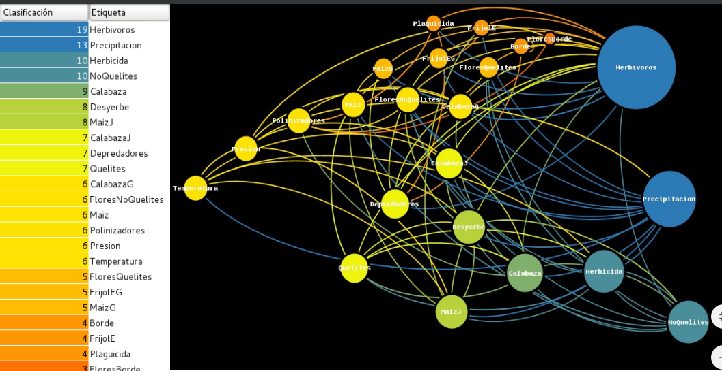

Figure 1: Graphical interpretation of the network. The size of each node represents its degree (number of incoming and outcoming connexions). Edges have the color of the node from which they originate.

**Interpretation of the boolean states**

In an ecological system, an activated node representing a taxon is interpreted as having a population density that is above some value that allows us to suppose a tendency to grow at the given time; and vice versa for an unactivated state. For the climatic nodes, there are thresholds for the temperature, rainfall and pressure values that once exceeded determine a change in seasons; the functions that rule this are nonlinear and variable, but in this case their boolean analogues reconstruct a viable dynamic for at least a warm or templated region with summertime rainfalls. As for the management nodes, the interpretation their discrete states is more direct, since they mean they are either practiced or not, e.g. manual weeding is either performed or not.

**Analyzing the dynamics of different management schemes: attractor interpretation**

We obtained a set of attractors for every treatment. The periodicity was ruled by the climatic nodes, which had periods of *6n* steps (each step representing two months). Hence, for the entire dynamic we only kept those attractors whose periodicity was also *6n*, since those were the ones that allowed for a yearly interpretation, in accordance with an agricultural cycle of six months of dry season and six months of rainfall (¿Figure?). This means that we kept the attractors where the dynamics of different periodicity, like the predator-prey and the floration cycles, spliced with the climatic period.

We used synchronous updating schemes, both deterministic and stochastic. This decision was taken because the bimonthly scale considered in the logical functions allowed us to assume that the elements had enough time for creating the interactions in question from one step to another. Also, synchronous behaviors are thought of as a parsimonious average of rather unknown asynchronies in the process (¿cita?).

Stochasticity was included for evaluating the attractors resilience under three kind of disturbances, with four intensity levels each. The disturbance types were: drought (non-activation of the rain node when it was supposed to be activated), rise in herbivory (activation of the herbivores node when it was supposed to be unactivated) and rise in weeds (likewise). These were applied like errors in the logical functions that regulated them, with four probabilities: 1/2, 1/4, 1/7 and 1/10 (Figure?). Attractors were obtained for each type and level of disturbance and compared to the deterministic undisturbed dynamics.

**Model’s assumptions: recapitulation**

* Synchronous updating with each step representing two months.
* We only considered the aerial part of the agroecosystem, excluding the soil dynamics.
* Nodes interact in a single plot’s scale with a homogeneous spatial distribution.
* The system’s richness in each treatment could only be diminished or kept, not raised. *I.e.* there were no invasions or node additions, only permanent non activations were possible.
* There is no energy gain or loss inside the system.

**- Función para generar estados iniciales (comvbase)**

Se construyó un algoritmo para, dados *n* nodos booleanos generar una matriz con todos los posibles estados iniciales, en donde cada columna representara uno de estos a manera de vector booleano.

**- Función para explorar los atractores a los que se llega partiendo de los diferentes estados iniciales (obtatrgenite)**

Se construyó una función para, dada una red booleana (sus nodos y sus funciones lógicas) explorar de manera exhaustiva y no exhaustiva los atractores a los que se llegaba partiendo de los distintos estados iniciales, cuantificando sus cuencas de atracción, devolviendo una lista de esta información y generando un gráfico de dichos atractores. Esta función presenta la peculiaridad de que permite realizar perturbaciones estocásticas dirigidas o aleatorias en los estados de los nodos, extender el análisis hacia redes multivaluadas, incorporar formalismos lógicos diferentes al clásico y realizar la actualización asincrónica de las funciones lógicas. Esta maleabilidad de la función repercute en la eficiencia de la misma, pero permite realizar exploraciones no exhaustivas de otro tipo de modelos.

**- Función para cuantificar la permanencia por atractor y por tratamiento (cuantiatr)**

Esta función toma como argumento de entrada la lista de atractores que arroja la función anterior y cuantifica la permanencia de la riqueza en cada atractor que tenga interpretación biológica. A su vez genera un gráfico y una serie de tablas en donde puede obtenerse el valor de la permanencia para las redes determinista y la permanencia promedio junto con su error estándar para las redes estocásticas. Esta misma función permite obtener la denominada permanencia conjunta (ver apartado 3.3.)

**- Función para realizar las comparaciones múltiples entre las permanencias por tratamiento (comparmult)**

Dados un conjunto de valores de permanencia, esta función realiza una serie de *k²* comparaciones (siendo *k* el número de conjuntos de datos a comparar) pudiendo realizar distintas pruebas estadísticas y generando matrices de comparaciones múltiples. El tipo de prueba que la función realiza por *default* es la prueba de Z y se utiliza la corrección de Sidak para calcular el valor de alfa con el fin de reducir la probabilidad de cometer un posible error de tipo I. Esto debido a que en las comparaciones múltiples se utilizan varias veces los mismos conjuntos de datos y puede ocurrir con una *p>0.5* que en 20 comparaciones con los mismos datos al menos una comparación resulte significativa por azar.

**Attractors for the deterministic treatments**

We analyzed 25 treatments with deterministic boolean networks (cero error probability in the state updating), which came from the different combinations of predictive variables: crop richness (5 levels along a simplification gradient) and management scheme (5 levels along a technification gradient). We explored each treatment non-exhaustively, i.e. we found the attractors for a sample of 3000 random initial states, with a hundred independent repetitions for each one. This decision was taken because:

1. The values in the basins of attraction stabilized (law of large numbers).
2. Generating independent repetitions allowed us to use the central limit theorem (cita?) for assuming a normal distribution of the values generated in them. This way, we were able to average them and use parametric statistics for their comparison.
3. The exhaustive exploration of 223 initial states was inefficient with this code

From the analysis of these 25 treatments we generated a control catalogue of results, which was to be compared with those obtained after the stochastic disturbances. Examples of the obtained results can be seen in Figure ¿?.

**Attractors for the stochastic treatments**

We analyzed 300 stochastic treatments (5 levels of crop richness, 5 management schemes, 3 types of disturbance, 4 levels of disturbance). As in the deterministic scenario, we generated a sample of 3000 initial states with 100 repetitions each.

**Permanence**

This concept was introduced by Hutson and Schmitt (1992) in the context of dynamic systems of differential equations, and is defined as follows:

*Permanence:* given the dynamic of a biological community, permanence is defined as the degree to which an initial richness is maintained as part of the habitual state of the system or after some disturbance.

This measure of change in richness breaks with the conventional idea of what makes an ecological system stable (cita?). It measures the frequency of appearance or disappearance of the elements in it, instead of penalizing fluctuations in their density. In the following we describe how we quantified individual and grouped permanence in the attractors found under the different treatments.

**Individual permanence**

Given some combination of initial crop richness and management scheme (treatment ***T***), we defined the permanence of a crop ***X*** in the attractor ***i*** as the following conditional probability:

***Ecuación 3.*** …(1)

Where:

- ***pi*** is the permanence of crop ***X*** in the attractor***i*** of treatment ***T***

By considering each attractor of period >=6 obtained under each treatment, we can count how many times crop ***X*** endured until the end of the season and divide it by the number of times that it was planted. Hence, we obtain the proportion of seasons in which we harvested the crop.

Once we obtained the permanence in each attractor, we defined the permanence of a crop ***X*** in treatment ***T*** as the hope of the permanences of each attractor for that treatment:

**Ecuación 4.**  …(2)

- ***pi*** is permanence for crop ***X*** in attractor***i*** of treatment ***T***

***- fi*** is the size of the basin of attraction of attractor ***i*** in treatment ***T***

***-*** Ecuación 5 is the permanence of crop ***X*** in treatment ***T***

***- k*** is the number of stable scenarios or attractors obtained for treatment ***T***

Then we calculated average permanence for 100 repetitions of each treatment as showed in **(3)**.

Ecuación 6 …(3)

Where:

-Ecuación 7 is equation **(2)** applied on repetition ***i*** of treatment ***T***

-Ecuación 8 is average permanence of crop ***X*** under treatment ***T***

**Grouped permanence**

In order to consider each agrosystem as a whole, we calculated a grouped performance measure that accounts for the performance of all present crops and quelites (which are also useable products for the peasant) in a plot. considerando el desempeño paralelo de los otros cultivos o la presencia de quelites como un recurso y producto del mismo. This measure was calculated for each treatment ***T***,both stochastic and deterministic, and their corresponding attractor ***i*** as follows:

Ecuación 9 …(4)

Where:

- ***pci*** is grouped permanence in attractor ***i*** of treatment ***T***

***- j*** is the j-ésimo crop or quelite. We should note that **1 ≤ *j* ≤ 4**

Then we calculated each treatment’s grouped permanence by averaging in the same way as in individual permanence:

Ecuación 10 …(5)

Where:

- ***pci*** is the permanence of crops or quelites represented by ***X*** in the attractor***i*** of treatment ***T***

***- fi*** is the size of the basin of attraction of attractor ***i*** in treatment ***T***

***-***Ecuación 11is the permanence of crops or quelites ***X*** in treatment ***T***

***- k*** is the number of stable scenarios or attractors obtained for treatment ***T***

Finally, we obtained average grouped permanence for each treatment ***T*** by obtaining the arithmetic average of the hundred repetitions as follows:

Ecuación 12 …(6)

**Multiple comparisons for individual and grouped permanence**

We assumed a normal distribution of permanence in the samples because:

1. Average permanence in each treatment was obtained from a hundred independent repetitions.
2. Permanence for each sample was calculated as another average (see (2) and (5).

Debido a que en cada tratamiento las 100 réplicas empleadas para obtener la permanencia promedio (individual o conjunta) fueron independientes unas de otras y a que ésta se calculó como un promedio de las permanencias muestrales, las cuales fueron obtenidas como otro promedio (ver (2) y (5) ), pudo suponerse una distribución normal para las permanencias muestrales.

This, added to the fact that the sample size of each treatment was large (*n=*100), allowed us to make multiple comparisons by means of Z tests (7) of average individual and grouped permanences between treatments. Because we made *m* multiple comparisons with the same data, we calculated significance with an alpha value obtained with Sidak’s correction (8) in order to avoid committing a type I error.

Ecuación 13 …(7)

Ecuación 14 …(8)

Afterwards, we constructed colored multiple comparisons matrixes in order to distinguish significantly different values from the rest. Color intensity indicates the size of the difference among values (as in heatmaps). We also made bar graphs of the individual and grouped permanences for some treatments of interest.

The construction process of these matrixes aimed to answer the next questions:

1. Does permanence vary under different disturbances?
2. Does average permanence vary under different levels of the same disturbance?
3. When controlling for type and level of disturbance, does permanence vary among different management schemes?

-

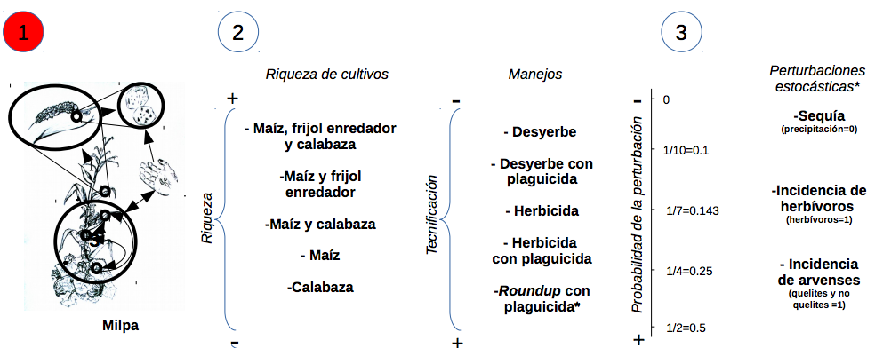

(traducir)

**Results**

**Principal attractors**

In the following we present the attractors obtained for the different treatments. Each column is a time step that represents the average state of a node during two months. As discussed in the Methods section, we only considered attractors of period >= 6. Because the model is boolean, yellow represents an activated node (1) and blue represents an unactivated node (0).

**0.a. Milpa with traditional management, *i.e.* border vegetation, manual weeding and policulture (maize, beans and squash) (deterministic)**

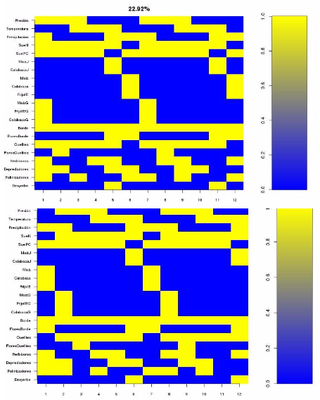

* We obtained two attractors of period 12 (two annual cycles), this results from the interaction of the climatic attractor (period 6) with a boolean Lotka-Volterra cycle between herbivores and their predators (period 4). The cycle of the three crop species is six months long.
* Manual weeding is performed at the start of the rainy season, when maize and squash are young.
* Climbing beans appear at the next bimester, because it needs young maize to climb on. Its cycle lasts less than maize’s and squash’s.
* Herbivores are present since the first crops appear, but the presence of border vegetation causes their predators to be exist, allowing the crops nodes to remain activated.

**0.b. Traditional management without border vegetation (deterministic)**

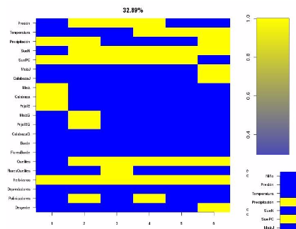

* As a part of simulation 0, we have a period 6 attractor when border vegetation is always inactive. Consequently, tbhere are no predators and herbivores are present all year since the appearance of crops and quelites. From this we should infer that productivity is diminished.
* Squash is not harvested. This is because there are no flowers in the border or in quelites that significantly attract its pollinators. Even though squash’s flower is present, it does not seem to be enough for guaranteeing its pollination.

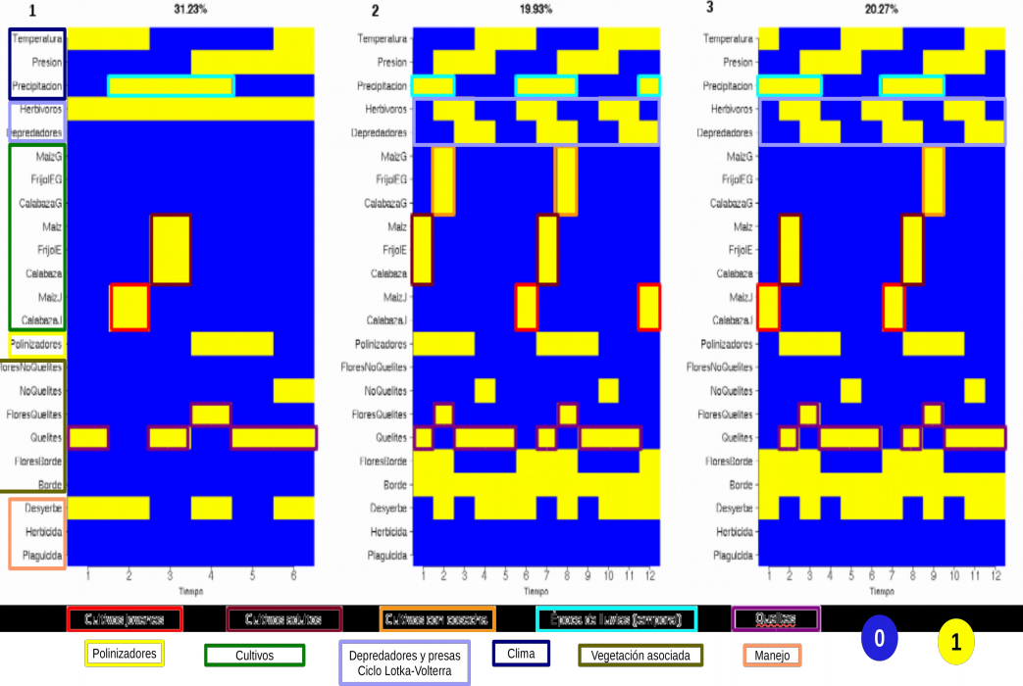

Figure: Attractors for milpa (maize, bean and pumpkin) with manual weeding and no perturbations. No siempre que se sembró alguno de los cultivos se logró una cosecha, en el atractor 1 se tiene un permanencia de 0/1=0 para los tres cultivos, en el 2 de 2/2 y en el 3 de 1/2. Cada instante temporal equivale a un bimestre.(traducir)

**1.a. Traditional management during “El Niño” (deterministic)**



* Here we present the same system as before, but with an artificially added climatic modification of the rain node which can be interpreted as a year with “El Niño” followed by a normal year.
* First, we can see a “normal” harvest cycle (analogous to the first two attractors of the previous simulation). Next, we find a second cycle interrupted by the lack of rain in which maize, beans and squash do not reach their adult phase.
* Herbivores and their predators have a normal cycle because of the presence of crops, quelites and border vegetation. Due to the presence of predators, even though crops did not reach the grain-producing phase, we should interpret that stubble was obtained (which can be useful for the soil or for animal food).
* As in the previous simulation, manual weeding and the planting of a legume has repercussions on the soil’s P, C and N content.

**1.b. Traditional management without border vegetation during “El Niño” (deterministic)**

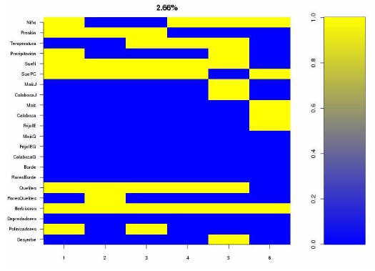

* Here we get a period 6 attractor in which adult crops are not obtained, as in the previous case.
* The lack of border vegetation results in the presence of herbivores throughout the whole year (because there are not enough predators to control them). This causes stubble to diminish.

**2.a. Traditional management during “El Niño” (deterministic-stochastic)**

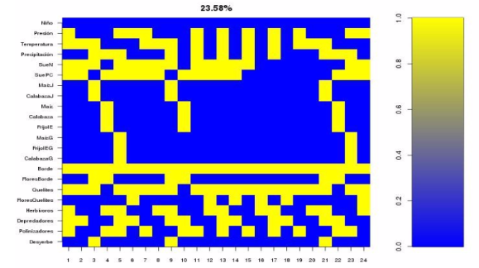

* In this case we didn’t create an artificial climatic modification of the rain node, but we added stochasticity by introducing a probability of error of 1/7 for the actualization of the rain node. We obtained various attractors; on the following we present those who were considered relevant and interpretable.
* We obtained an attractor of period 24 interpretable as a four year dynamic.
* In the first year (the first 6 states), the dyamic of crops, associated vegetation and other niches remain unaltered.
* During the second year (states 6 to 12) crops do not reach their adult phase due to the lack of rains.
* The third year’s (states 12 to 18) rain pattern is such that not even young crops are obtained, though quelites and border vegetation are present and they allow for the herbivore, predator and pollinator dynamics to remain normal.
* On the fourth year (states 18 to 24) the usual rain dynamic is reestablished and crops reach adulthood.

**2.b. Traditional management without border vegetation during “El Niño” (deterministic-stochastic)**

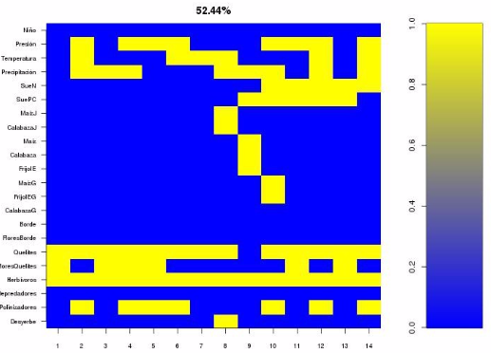

* We obtained a period 12 attractor much more drastic than its deterministic counterpart.
* We have one normal year for the crops and one where there are no conditions for their growth, soil is impoverished and only quellites are present, *i.e.* we have an “acahual”.
* The lack of border vegetation and the consequent presence of herbivores lets us interpret that even the year where crops are produced, their harvest is diminished.

**3.a. Maize monoculture with traditional management (deterministic)**

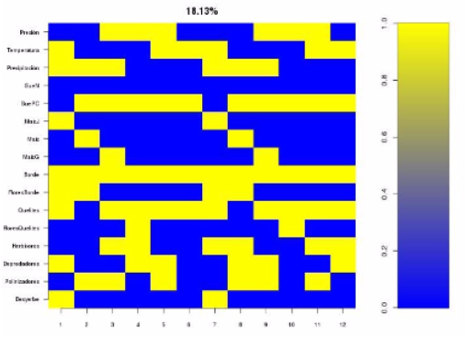

* Again, the climatic and the Lotka-Volterra cycles generate an attractor of period 12.
* The presence of border vegetation maintains a normal dynamic between herbivores and their predators.
* Soil is impoverished regarding N, which is due to the absence of a legume.

**3.b. Monocultivo de maíz con manejo tradicional sin borde (booleano determinista)**

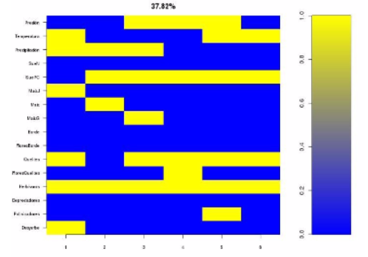

* The soil is also impoverished regardin N.
* The lack of border and the consequent lets us infer a suboptimal productivity for this system.
* Even though maize does not need pollinators, pollination as an ecosystem service is absent.

**4.a. Maize monoculture with traditional management during “El Niño” (deterministic)**

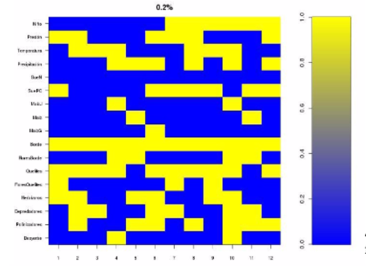

* This dynamic is not very different from its polyculture counterpart, but we can see that the soil is impoverished regarding N, P and C.
* Again, adult plants are not obtained during the year with “El Niño”.
* The presence of border vegetation and quelites allows the other organisms in the network to maintain their regular dynamic.

**4.b. Maize monoculture with traditional management without border vegetation during “El Niño” (deterministic)**

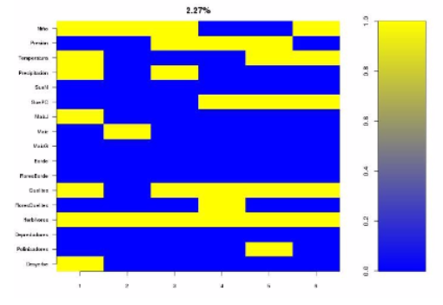

* We find a clear decrease in the number of active nodes in this attractor.
* There are no adult crops and the amount of herbivores is such that stubble is probably not satisfactory.
* Soil is impoverished regarding P, C and N.

**5.a. Maize monoculture with traditional management during “El Niño” (deterministic-stochastic)**

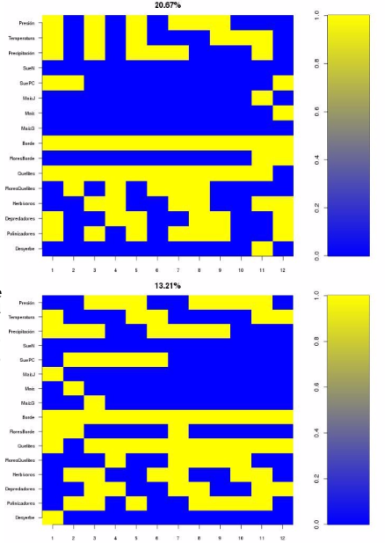

* Again we added stochasticity for the rain node, maintaining the same probabilities (3/4 chance of maintaining the value assigned by the logical function and 1/4 chance of changing it)
* During the first year, maize cannot even reach its young phase and on the second year it does not reach adulthood.
* In the second attractor the rain pattern is only altered on the second year, allowing maize to reach adulthood on the first year.
* Border vegetation and quelites maintain the diversity of other organisms but soil remains impoverished in both attractors.

**Comparing permanence among treatments**

Table 1 shows the tested variables, from which we had the following number of treatments:

5x5x3x4 disturbed treatments + 5x5 undisturbed treatments (controls) = 325 treatments ***t***.

|  |  |
| --- | --- |
| Predictive variables | Response variables |
| Crop richness (5 combinations)  Management scheme (5 types)  Disturbance type(3 types)  Disturbance level (4 levels) | Individual permanence of each crop  Individual permanence of quelites  Grouped permanence of crops and quelites. |

Table 1: predictive and response variables tested.

With this size of ***t***, the number of paired comparisons was 3252. These are represented by the following comparison matrix ***C***:

Ecuación 15

Where ecuación 16 is the difference in permanence between treatments ***i*** (row) and ***j*** (column). We considered Δ P Ij = 0 if the difference between treatments i and j was not statistically significant or if such comparison lacked sense, e.g. a comparison of individual permanences of corn between treatments which initial richness comprised only squash. The matrixes were presented as heatmaps, with significant comparisons varying in color intensity according to the magnitude of their value and nonsignificant comparisons being gray. Then we filtered nonsignificant comparisons in order to present clearer, shorter matrixes and we presented the remaining comparisons as absolute values, in order to focus on their magnitude rather than their sign. We only present in this paper those matrixes which answer specific questions, the rest can be found in the supplementary material.

**How do different types of perturbation affect permanence?**

Variables set constant: perturbation level (e.g. P=1/10).

Comparison made: permanence values with different types of perturbation, for each management scheme and crop richness.

In Figure ? we can see that the disturbance with a bigger effect on permanence was the rise in weeds, followed by ___ and finally ___. This is consistent with what Vandermeer (2010, p. 42) proposes, this is, that after working two or more times on the same plot, soil’s loss of fertility and the rise in weeds are the main factors causing a chronic reduction on productivity.

**How does management scheme affect permanence?**

The treatments with manual weeding and pesticide use obtained the highest individual and grouped permanences (Figure ?same as previous question ). This can be observed by following the horizontal yellow lines related to the treatment found in the left margin of each graphic. A possible explanation for the superiority of treatments with pesticide over treatments with manual weeding only is that the use of pesticide breaks the predator-prey cycle that characterizes all attractors, …

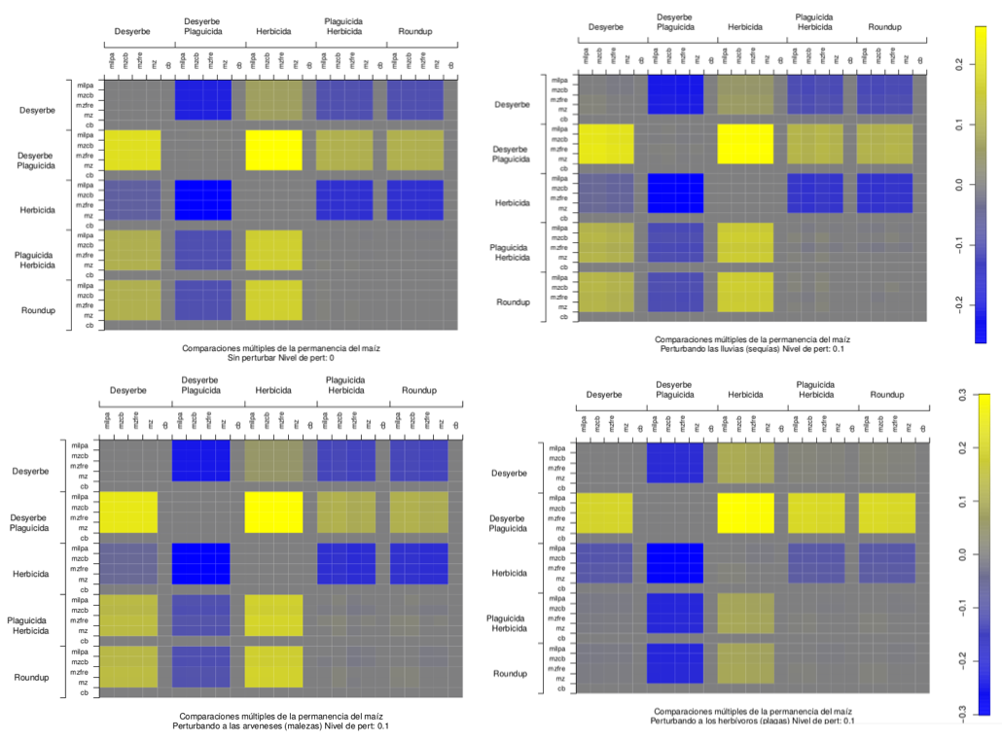

Figure: Comparaciones múltiples, filas respecto a columnas, si la celda es amarilla, la permanencia correspondiente al tratamiento de la fila es mayor que la de la coumna correspondiente, si es azul es menor y si es gris no hay diferencias significativas. comparando las permanencias del maíz fijando un nivel, de perturbación de 0.1, pueden observarse los tres tipos de perturbación y el tratamiento determinista. La categoría externa es el manejo (eje externo) y la categoría interna es la riqueza de cultivos.

**How do different levels of each disturbance affect permanence?**

Variables set constant: disturbance type (e.g. drought).

Comparison made: permanence values with different levels of disturbance, for each management scheme and crop richness.

In Figure ? we can see that permanences follow an expected behavior in which lower values are found for the higher disturbance level and then rise as such level diminishes. Curiosamente al observar el siguiente Gráfico puede notarse un aumento de las permanencias de los cultivos al comparar el menor valor de perturbación (P=1/10) con el tratamiento determinista , este fenómeno se denomina en otras áreas como resonancia estocástica y permite sugerir la hipótesis de que las permanencias reales de un agroecosistema sujeto al “azar” pueden presentar comportamientos contraintuitivos pero las tendencias generales son las esperadas.

**How does the drought disturbances affect permanence?**

**How is permanence affected by the level of crop richness?**

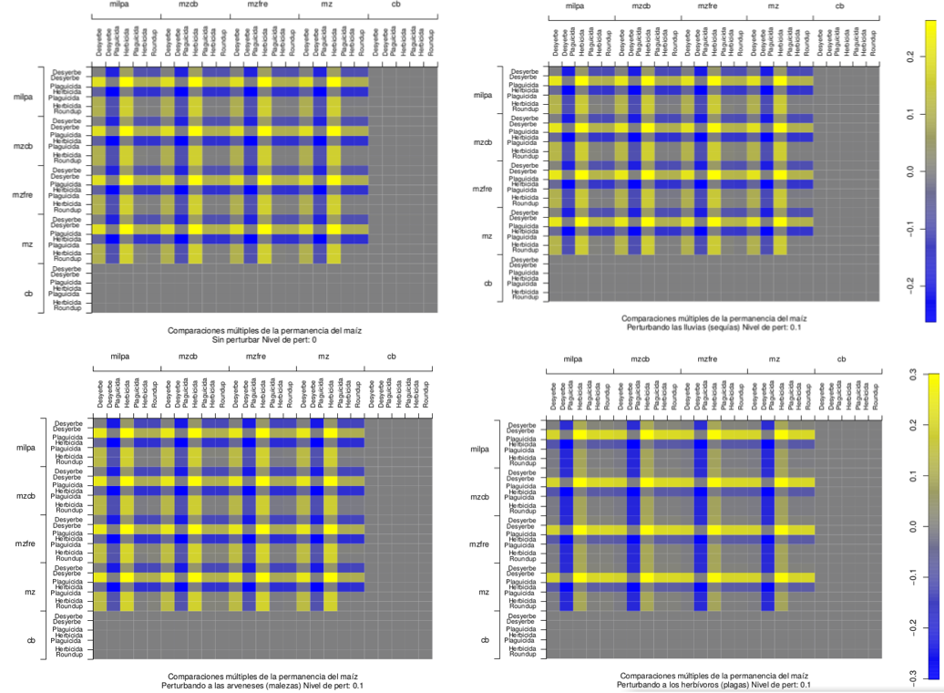

Figure: Lo mismo que en la anterior pero reordenando las categorías de comparación, aquí la categoría externa es la riqueza y la interna el manejo. **Esto no sé si ayuda a responder la pregunta, no me es clara la interpretación de la figura**

**Quelites and grouped permanence.**

The visual pattern generated by individual quelite permanence and grouped permanence in each treatment (Figues) have a similar tendency. This means that quelites have a very strong influence over grouped permanence. This is consistent with Vandermeer (2009), Vibrans () and Vieyra Odillón(), which remark that the largest amount of richness found in the milpa system is composed of plant species that are not actively planted by peasants, but merely tolerated or favored.

**Esto no es también un input más que un output del modelo, por la forma en que se calcula la permanencia conjunta?**

Another result is that permanence is higher for the maize monoculture and for the beans and maize treatments. In other words, quelites permanence (hence, grouped permanence too) are higher when there is no squash. This is probably due to the fact that quelites compete for space with squash.

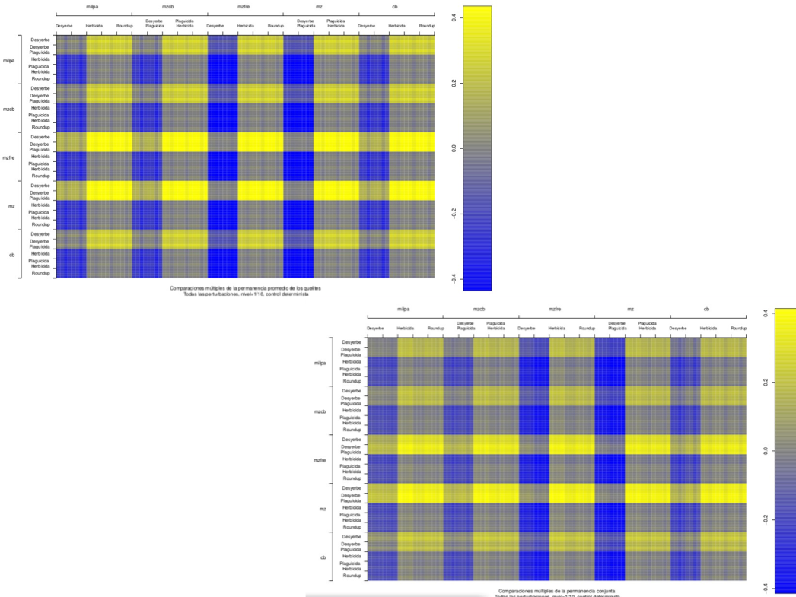

Figure: quelites permanence (top left) and grouped permanence (bottom right) are very similar. In both cases, permanence is higher for the treatments without squash. All disturbances, level 1/10, **deterministic control?**

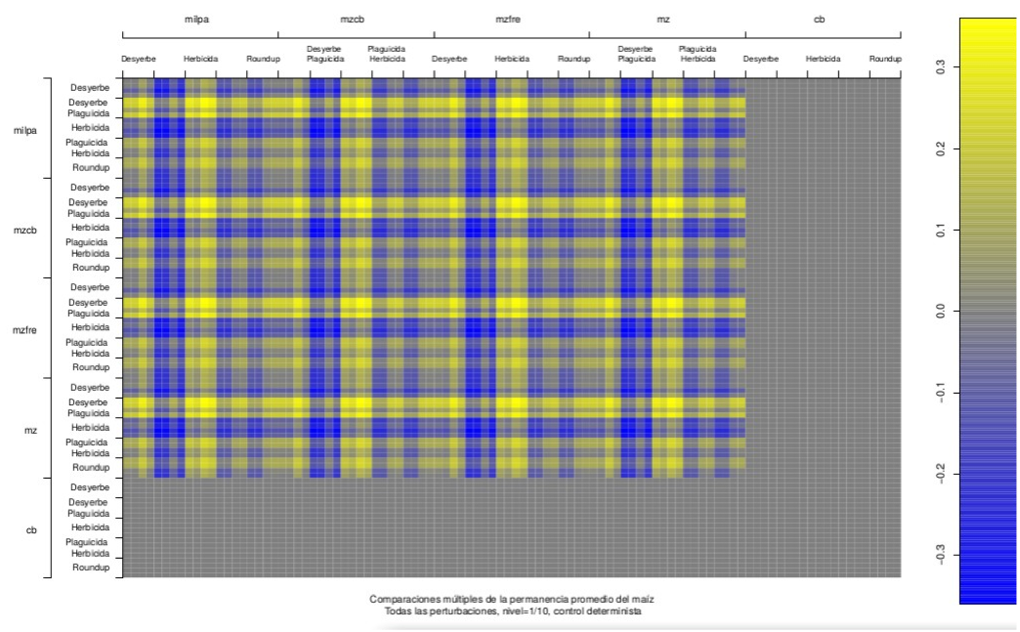

Figure: 37- Lo mismo que la 35 pero uniendo todas las perturbaciones en una misma gráfica. **Esta creo que se puede quitar, es más clara la figura con las perturbaciones por separado. No?**

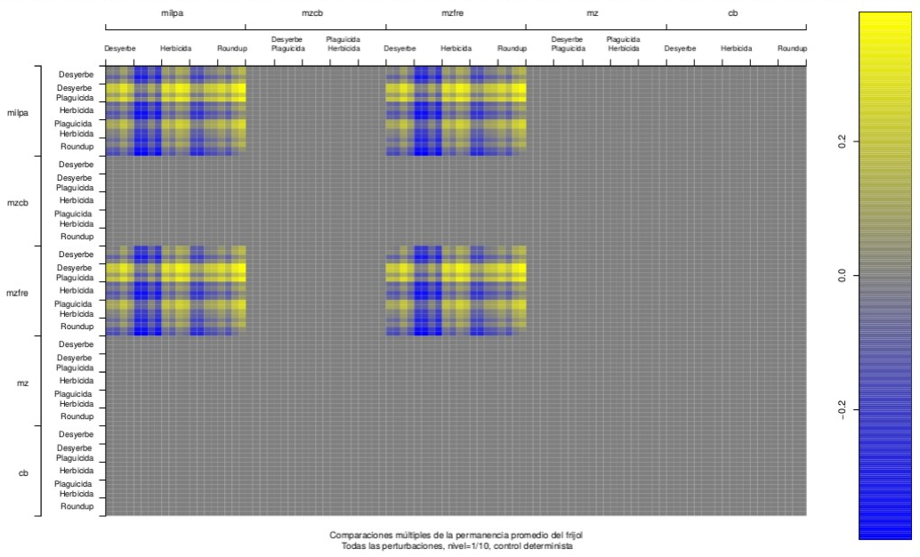

Figure: Gráfico de la permanencia del frijol, sólo para mostrar cómo su comportamiento es un subconjunto del comportamiento del maíz (relación ecológica muy cercana). **Esta con su propio subtítulo o en suplementario?**

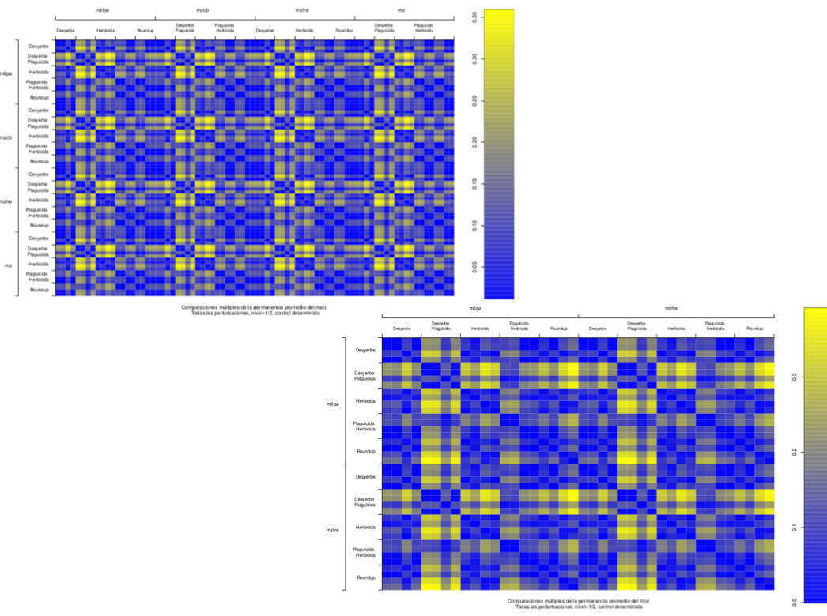

Figure: Gráficos 37 y 38 pero con valor absoluto. **Qué se gana viendo esta gráfica? Si se quita habría que quitar la mención más arriba al valor absoluto.**

**Looking deeper into some interesting treatments**

In Figure ? we compare permanences among a crop richness gradient, both for the deterministic control and the case with a 1/10 probability of error in the rain node. These were all tested under the manual weeding management scenario. **Yo sólo veo el resultado ya dicho de que la permanencia de quelites y conjunta crecen cuando no hay calabaza. Hay algo más que no estoy viendo?**

In the next figure we present the same analysis under a management scenario with herbicide and pesticide use instead of manual weeding. **Lo que yo veo es que no hay calabaza, pues el herbicida la mata, supongo. También hay menos quelites y por lo tanto menor permanencia conjunta debido probablemente a que el herbicida los mata, en todos los casos la permanencia de quelites es menor incluso que en los casos sin calabaza de la simulación de arriba. La permanencia de maíz y frijol es mayor que en la del caso anterior, pero solo sube de .4 a .5, a Costa depender la calabaza y de que los quelites y la conjunta descienda como en .2, al menos.**

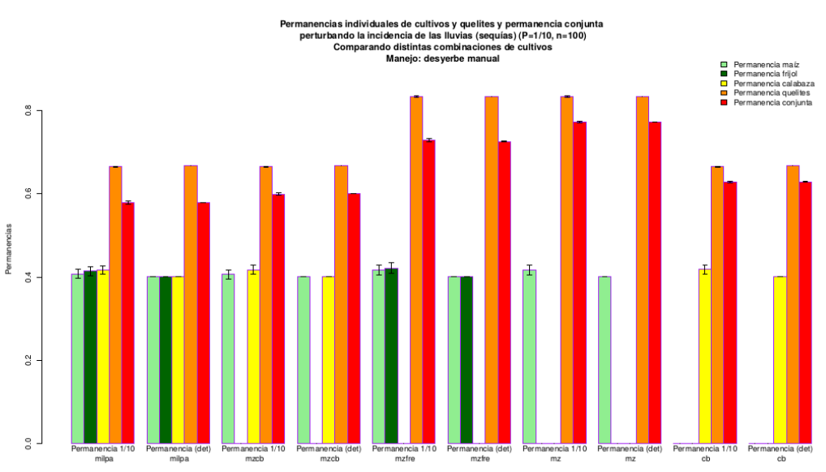

Figure: In the X axis, a crop richness gradient. Permanences in the Y axis (maize, beans, squash, quelites and grouped). Each treatment is analyzed pair-wise, presenting first the case with a 1/10 disturbance probability in the rain node, followed by its deterministic counterpart. All cases were analyzed under a manual weeding management scenario.

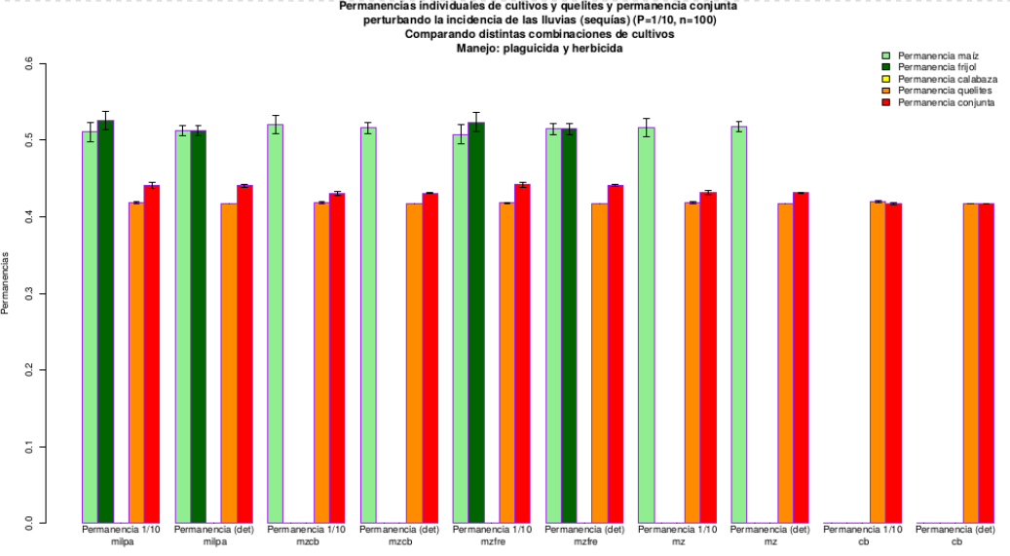

Figure: In the X axis, a crop richness gradient. Permanences in the Y axis (maize, beans, squash, quelites and grouped). Each treatment is analyzed pair-wise, presenting first the case with a 1/10 disturbance probability in the rain node, followed by its deterministic counterpart. All cases were analyzed under a management scenario with pesticide and herbicide use.

Next we present the effect on the different permanences of a management technification gradient: manual weeding, manual weeding and pesticide, herbicide, herbicide and pesticide, and finally Roundup. Again, treatments with a 1/10 chance of error in the rain node are followed by their deterministic control. All treatments were analyzed under a richness scenario were all crops (maize, beans and squash) are present.

**Veo que la diferencia entre perturbado y control es casi nula. También veo que el plaguicida se echa a la calabaza (por sus polinizadores, supongo) pero aumenta maíz y frijol, dejando quelites y conjunta casi igual (es el mejor de los casos). Después, la aparición del herbicida acaba por completo con la calabaza y hace que los quelites y la conjunta desciendan. El herbicida solo es el peor, pues maíz y frijol son los más bajos, herbicida con plaguicida alcanza niveles un poco más altos de maíz y frijol, finalmente Roundup deja maíz casi igual pero baja frijol.**

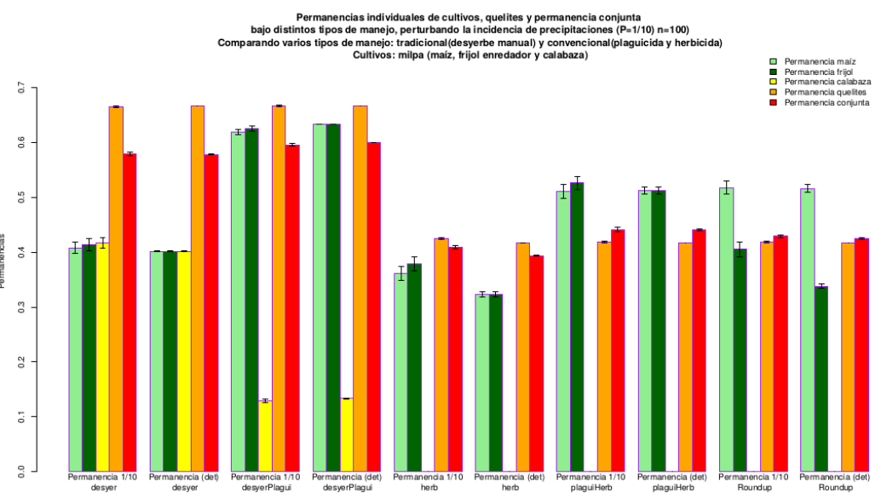

Figure: Technification gradient in the X axis. Permanences in the Y axis (maize, beans, squash, quelites and grouped). Each treatment is analyzed pair-wise, presenting first the case with a 1/10 disturbance probability in the rain node, followed by its deterministic counterpart. All cases were analyzed under a richness scenario where all crops are present (maize, beans and squash).

Up to here, we have seen comparisons of different management schemes in the face of a fixed perturbation in the rain regime of 1/10. Now we shall see comparisons of traditional and conventional managements along a gradient of perturbations.

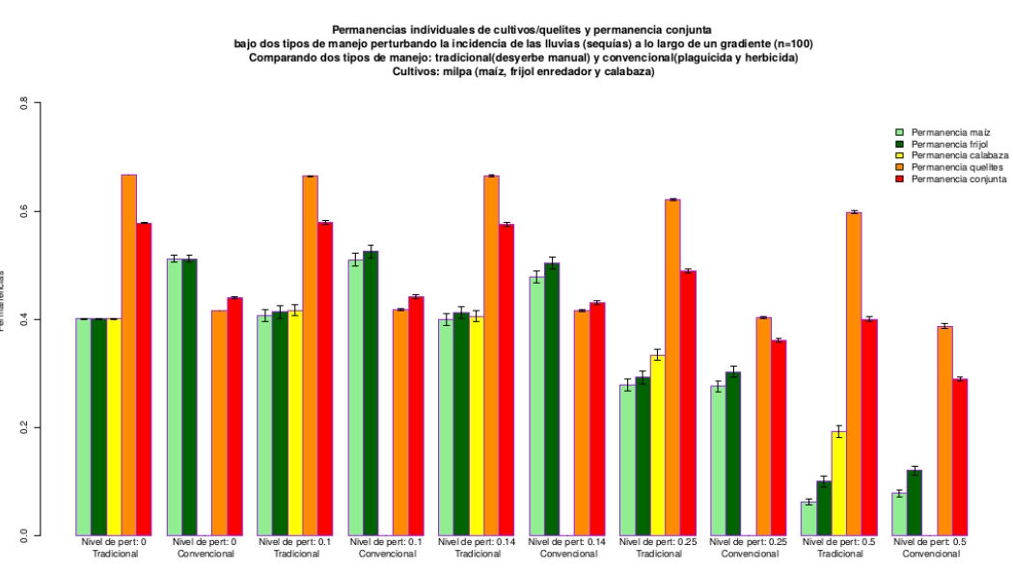

Figure: Comparison of traditional (manual weeding only) and conventional (herbicide and pesticide use) management schemes along a gradient of rain disturbances (probability of error in the rain node, from left to right: p=0.0, 0.1, 0.14, 0.25, 0.5). **Veo que la calabaza no existe en el convencional, debido al herbicida, supongo. Para p=0, el convencional gan aen maíz y frijol y pierde en quelites y conjunta. Para p=0.1 y 0.14, se mantiene maomeno el mismo escenario. Para p=0.25, los cultivos caen en ambos tipos de manejo pero caen más en el convencional, llegando a parecerse mucho la permanencia en ambos tipos de manejo; quelites y conjunta también caen un poco en ambos casos pero siguen ganando en el tradicional. Para p=0.5, los cultivos de nuevo decaen considerablemente pero quedan prácticamente iguales entre ambos manejos; quelites y conjunta mantienen el mismo patrón en que el manejo tradicional gana.**

Next, we performed the same comparisons but along a gradient of weed disturbances. In this case, we proved different probabilities of error in the actualization of the weed node. 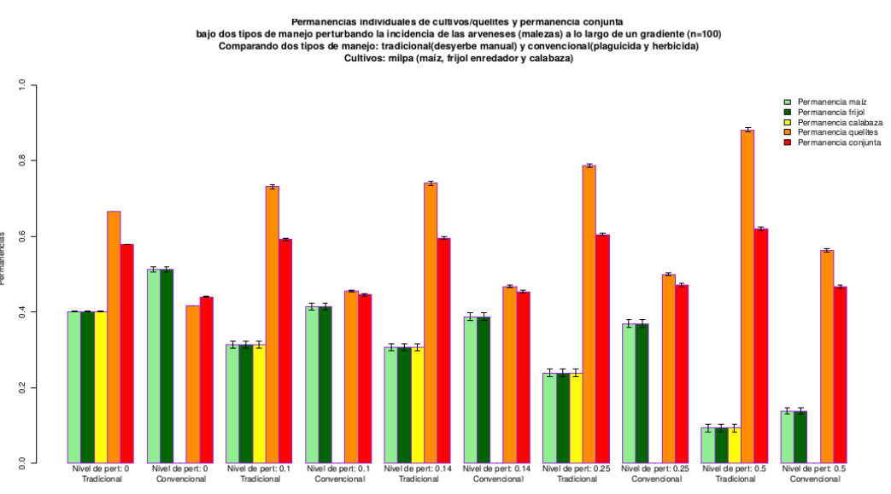

Figure: Comparison of traditional (manual weeding only) and conventional (herbicide and pesticide use) management schemes along a gradient of weed disturbances (probability of error in the weed node, from left to right: p=0.0, 0.1, 0.14, 0.25, 0.5). **Again, maize and bean permanence is larger in the conventional management, a pattern that is kept even for the largest disturbance probability. Squash is absent from the conventional management for the same reasons as before. As for quelites and grouped permanence, they are always larger for the traditional management scheme. Interestingly, they become larger in all cases as the disturbance probability rises. (This is because disturbing the weed node…?)**

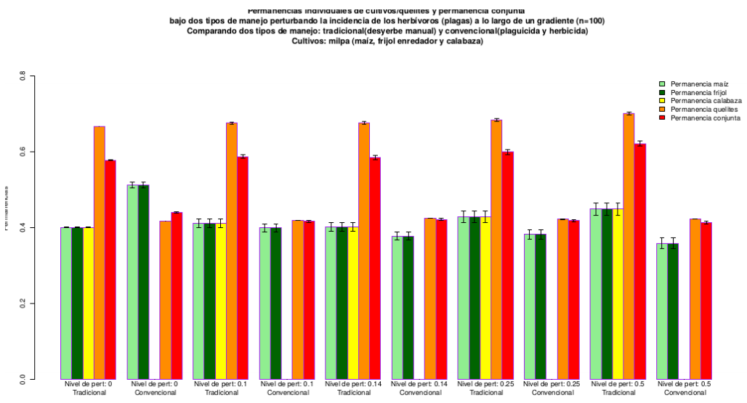

Figure: Comparison of traditional (manual weeding only) and conventional (herbicide and pesticide use) management schemes along a gradient of herbivory disturbances (probability of error in the herbivores node, from left to right: p=0.0, 0.1, 0.14, 0.25, 0.5). **In this case maize and bean permanences are only larger for the conventional management scheme in the p=0 scenario, at p=0.1 they are the same for both schemes and for the rest of the disturbance gradient, they become increasingly higher under traditional management. Quelites and grouped permanences are always higher under traditional management, and remain quite unvariable along the entire gradient. As always, squash is absent from the conventional management scheme.**

**Discussion and Conclusions**

-Importance of considering the vulnerability of the systems in the face of possible perturbations (climatic change, pests, etc.) and not only net productivity when assessing the desirability of different management schemes. According to an official assessment in Mexico (Encuesta Nacional Agropecuaria 2014 SAGARPA, INEGI), the principal problems that producers face in their activity are: high input and services costs (83.4%) and crop losses due to weather, pests, diseases, etc. (78.2%).

- Conclusiones de Rafa:

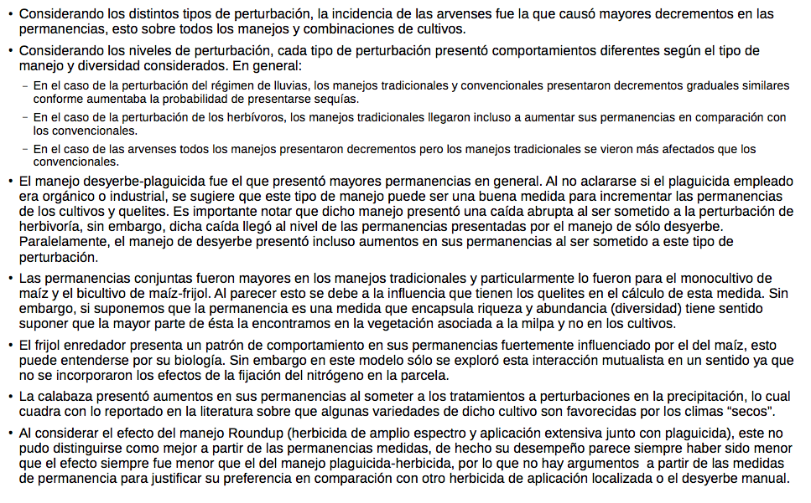

**Acknowledgements**

Mariana Esther, CONACyT David, PAPIIT Lev, CONACyT Prob Nac, Molote Agroecológico, Members of La Parcela Lab, …

**References**

INEGI, SAGARPA. Encuesta Nacional Agropecuaria 2014. Conociendo el campo de México, Resultados.

Vandermeer, J. H. (2010).The ecology of agroecosystems.*Structure*.

**Supplementary Material**

**Table S1:** Interactions between nodes of the model. These include a brief description and the principal references used to determine them.

Montón de gráficas